Smart Room Energy Saver

Team Members
- James O’Sullivan – S00290432@atu.ie
- Dede Coughlan – S00290949@atu.ie
- Eanna Gallagher – S00290069@atu.ie

Trello Board
https://trello.com/b/mSnvlSxd/iot

GitHub Repository
https://github.com/Jamesos86/IoTproject

Data Links
(link cloud or other thing here)

Outline of Problem
Energy use in homes accounts for a large share of global electricity consumption. As the population grows and towns/cities expand, the need for energy keeps rising. The United Nations highlights energy efficiency as an important part of sustainable development, especially through Sustainable Development Goal 7: Affordable and Clean Energy, and Sustainable Development Goal 13: Climate Action (United Nations 2015). Improving energy use in homes is not just a financial issue, but also a way of helping our environment.
In many homes, heating and lighting systems may operate at full capacity even when certain areas are empty. These actions, while appearing minor, add up to large amounts of energy waste (International Energy Agency, 2023). This leads to wasted electricity, higher heating bills, increased carbon emissions, and a setback in general sustainability efforts.
Research shows that everyday habits play a huge role in energy waste within the home. Many people do not realise how quickly small actions, such as forgetting to turn off the lights or heating, add up over time. Changing these habits can greatly lower energy consumption without needing large adjustments to the building itself. Simply being aware and monitoring your energy consumption can encourage more responsible energy use and result in long term savings.
Although smart technologies can help by automating lighting and heating controls, they can be costly to install and maintain. This makes them less accessible to students or low-income households that might benefit from the savings of lower energy bills. This situation can create a divide between available technology and those who can afford it. To improve energy efficiency in homes, we need a cost-effective solution that is practical and promotes us to change our habits. By focusing on these easy to implement strategies, we can help households cut down on energy waste, save money, and play a meaningful role in global climate action.
To further investigate, we conducted a small survey of 18 college students aged between 17-21 about their energy use habits in the home. We found that 72% admitted to regularly leaving the lights on in unoccupied rooms, while 55% said that the heating is often left on in parts of the house that are not being used. This further proved to us that this issue should be tackled for our project.
References
- United Nations (2015) Transforming our world: The 2030 Agenda for Sustainable Development. New York: United Nations.
- International Energy Agency (2023) Energy Efficiency 2023. Paris: IEA
Summary of the Smart Room Energy Saver
The Smart Room Energy Saver is a device that helps reduce energy waste in rooms. It uses a computer called Arduino to control the heating and lighting. The device checks if someone is in the room using sound sensors. It improves energy efficiency by turning off the lights and heating if no one is present. It also regulated heating while the room is occupied, keeping the temperature at a standard level. By combining components from the Arduino starter kit, the project provides a low cost and accessible alternative to expensive commercial systems.
At the core of the system is the Arduino Uno microcontroller, which acts as the central processing unit. The Arduino continuously gathers data from sensors around the room. A sound sensor is used to detect occupancy or any activity within the space. A temperature sensor measures the room temperature, while a light sensor monitors the brightness level of the environment. These inputs allow the system to make automated decisions about when heating or lighting should be activated within the room.
The Smart Room Energy Saver automatically controls two main outputs, a simulated heater, and a lighting system. The heater is controlled through a relay module, which allows the Arduino to switch the heater on/off safely. The lighting system is represented by an LED, which simulates the room lighting. In a proper real-world use of this system, this could instead be connected to a lamp or other household lighting system.
The system is also equipped with Wi-Fi capabilities, allowing it to send data to a could database. This allows the user to see energy usage patterns, occupancy duration, and just standard system activity. Cloud connectivity enhances the project by allowing the tracking of this data, which can then be analysed to help users better understand their energy consumption habits over time.
It works by using clearly defined temperature and occupancy thresholds. If the room temperature drops below 18°C, the system automatically turns the heater on. This ensures the room is always comfortable while a person is present. Once the temperature rises above 21°C, the heater automatically turns off. This prevents overheating and keeps the room at a standard ideal temperature.
Occupancy detection also plays a key role in the device’s efficiency. The sound sensor monitors activity within the room. If no sound or movement is detected above the threshold for five continuous minutes, the system assumes that no person is present. As a result, both the lights and heater are automatically switched off. This prevents energy waste from appliances running in occupied rooms.
Each time the system activates or deactivates the heater or lights, a timestamp is recorded and sent to the cloud. The total duration of the room occupancy is also logged. Over time, the data can be analysed to identify trends for the user, such as peak usage hours or long periods of inactivity in the room. This feature should transform the prototype from a simple automation device into a smart monitoring tool.
This system has several important outcomes. Firstly, it improves energy efficiency by ensuring that heating and lighting are only used when necessary. Secondly, it introduces automation, reducing the need for manual control, and lowering the risk of human error, such as leaving the lights on when not using the room. Thirdly, it supports sustainable living by helping to reduce carbon emissions produced by electricity use. Finally, by minimising the amount of energy wasted, the system reduces energy bills, making it financially beneficial for the user.
Unlike many commercial smart home systems, this prototype is designed to be affordable and accessible. It uses only widely available components and simple programming logic. Making it suitable for all budgets. It is designed for a wide range of users. Homeowners particularly can benefit from the automated energy management. Utilising it in unused rooms such as guest bedrooms or offices. Students living in rented accommodation may find merit out of the system as well, as it helps keep their energy bills low without modifying the room.
Environmentally conscious people who wish to reduce their carbon footprint can use the system as a sustainability tool. Additionally, small office spaces may use it for the automated heating and lighting, especially in meeting rooms, which are often left unused between bookings.
Overall, the Smart Room Energy Saver provides a practical, cost-effective solution to reduce energy waste. The sensor-based monitoring, automated control, and cloud data logging demonstrate that simple, but effective IoT technology can contribute in a meaningful way for sustainable living.

Project Requirements
- Detect room occupancy using a sound sensor.
- Monitor ambient temperature.
- Monitor ambient light levels.
- Automatically control heating through a relay.
- Automatically control lighting through a LED.
- Send data to cloud database.
- Reconnect automatically after Wi-Fi disconnection.
- Store timestamps of room usage.

Initial Design
Proposed device
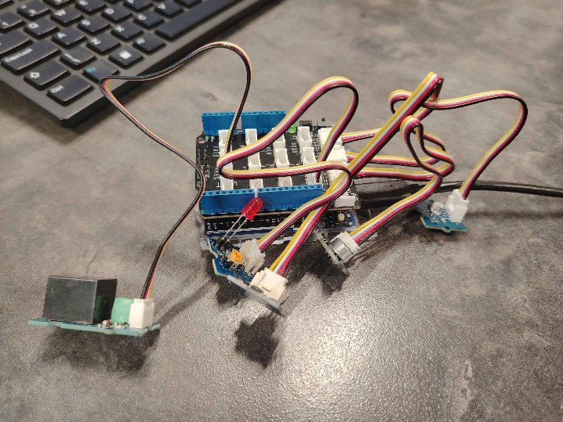
- Arduino Uno in the centre.
- Temperature Sensor connected to A0.
- Light Sensor connected to A1.
- Sound Sensor connect to A2.
- Relay Module connected to Digital Pin 5.
- LED connected to Digital Pin 4.

Proposed Code
Setup():
- Initialise sensors.
- Connect to Wi-Fi.
- Initialise relay + LED.
Loop():
- Read temperature.
- Read light level.
- Detect sound activity.
- Check inactivity timer.
- Control heater.
- Control lighting.
- Send data to cloud.

Hardware Setup
- Arduino Uno
- Temperature Sensor
- LDR Light Sensor
- Sound Detection Module
- Relay Module
- LED
- Wires

API / Data Processing
The system sends occupancy and temperature data to a cloud database, it shows:
- Timestamps
- Temperature
- Light level
- Occupancy status
- Heater status
- Light status

Code Samples
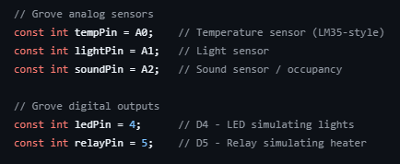
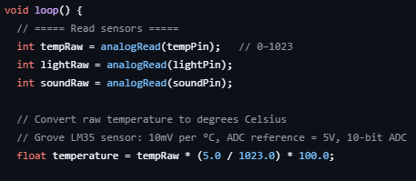
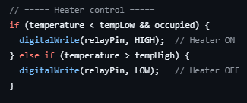

Testing Approach
We took a hands-on approach to testing the Smart Room Energy Saver, making sure both the hardware and software worked the way we planned. We ran these tests in a controlled environment, so we could see how accurate, responsive, and stable the system was when being used.
For hardware, we started by checking the sensors and outputs. To test the temperature control, we faked different readings near 18°C and 21°C, just to see if the heater turned on and off when it should. We also muted the sound sensor to mimic an empty room. This let us check if the system could spot when no one was around and then turn off the light and heater after five minutes. We flipped the relay on and off a bunch of times to make sure it worked every time and watched the lighting to see that the LED turned off when it was supposed to.
On the software side, we double checked all the programmed rules. We paid extra attention to timing, using the millis() function to make sure the system tracked inactivity without freezing or slowing down. For Wi-Fi, we turned off the hotspot we were using to lose the connection on purpose, then watched if the system could reconnect by itself and start sending data back to the cloud without us having to restart anything.
Of course, a few problems popped up. At first, the sound sensor was too sensitive and kept thinking someone was there when the room was empty. Sometimes, after we forced the Wi-Fi to disconnect, it wouldn’t reconnect on its own. And the relay created some electrical noise that messed with the sensor readings. We sorted these out by moving them apart and tweaking the sensor threshold. We also added short delays to filter out the noise. After that, the system became more reliable and accurate.
Security Analysis
While building the Smart Room Energy Saver, a few security risks popped up. Wi-Fi credentials could show up in the source code. If someone got their hands on that, they could jump onto the local network with no trouble. Same went for API keys. Someone could mess with the cloud database if they got access to them. There is also the chance of someone intercepting data if the connection between the device and the cloud isn’t locked down with encryption. That kind of unauthorised control could jeopardise everything on the device and network.
Our solution to keep things safe was to have the Wi-Fi credentials in a separate header file, kept out of places like GitHub so they couldn’t accidentally go public. Authentication tokens make sure only the right device talks to the cloud database. We also closed any unnecessary ports on the device, making it harder for outsiders to get in.

Future Improvements
While the Smart Room Energy Saver prototype successfully demonstrates automated heating and lighting controls, several improvements could significantly improve its accuracy, functionality, and usability in future iterations.
One major improvement would be replacing the sound sensor with a Passive Infrared (PIR) motion sensor. Although the sound sensor can detect activity, it is prone to false triggers from background noise and may fail to detect quiet occupants. A PIR motion sensor would provide a more reliable and precise occupancy detection by identifying body heat and movement. This change would improve overall system accuracy and reduce false flags.
Another important enhancement would be the addition of real time energy consumption measurement. Currently, the system simulates heater and lighting control but does not calculate the exact amount of electricity being used. By adding a power monitoring sensor, the system could measure the actual energy usage. This would let the user know the precise energy saving over time.
Developing a web dashboard of some kind would also improve usability. It could display room temperature, light levels, occupancy status, heater activity, and plenty of other metrics. This would make the system more usable and user friendly. This could be paired with a mobile app to let the user view all this info anywhere from their phone.
The project could also be expanded into a multi-room system. By connecting multiple sensor units to a central hub, the Smart Room Energy Saver could manage an entire house or office building rather than a single room. This makes it significantly more applicable in a real-world environment.
Finally, integrating solar energy monitoring would help in the sustainability goals. If connected to a solar panel system, the device could prioritize using renewable energy when the available and adjust heating and light usage accordingly. This would support greener energy consumption, aligning with our long-term environmental goals.
Overall, these future improvements would transform the Smart Room Energy Saver from a functional prototype into a fully integrated smart energy management system.

